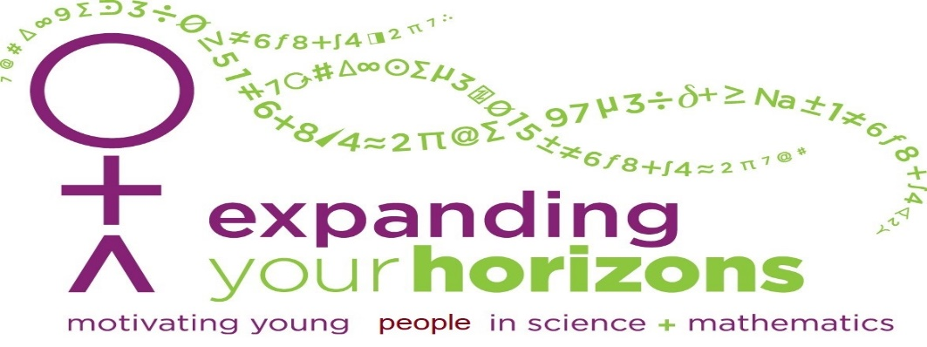

11.1.25

SATURDAY

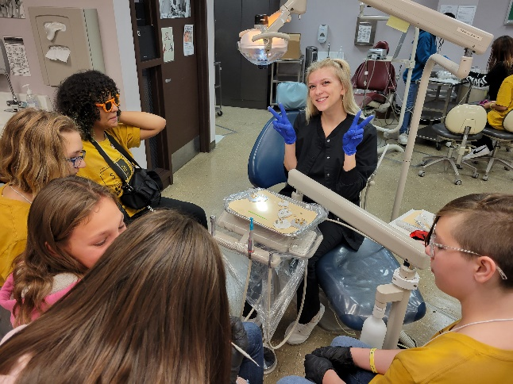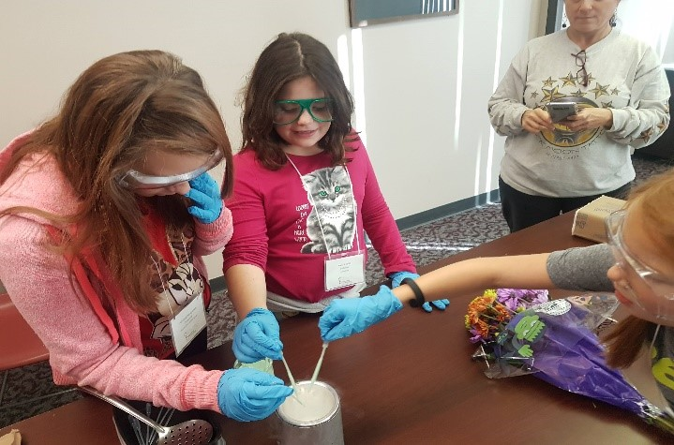

A motivating, fun-filled conference for 5th, 6th, 7th, 8th, & 9th grade students.

Conference Highlights

Participate in 3 exciting career workshops presented by professionals.

Get answers and inspiration from successful scientists. They did it, so can you!

Meet young people in Southern Illinois with interests and questions similar to yours.

SCHEDULE

CONTACT INFO

***Come on your own or as a class/group.***

08:45 a.m.

09:15 a.m.

09:35-10:35

10:55-11:55

12:05-12:45

12:55-1:55

02:00 p.m.

Registration Welcome Workshop I Workshop II Lunch Workshop III

Participant Pickup

Student Center International Lounge Student Center Auditorium

As Assigned As Assigned

Student Center Ballroom B

As Assigned

Student Center International Lounge

See your Science/Math Teacher for group registration, or register on your own.

For information, contact the School of Mathematical & Statistical Sciences, SIUC

# [618.453.5302](mailto:eyhmath@siu.edu)

[eyh](mailto:eyhmath@siu.edu)[math@siu.edu](mailto:math@siu.edu)

or check us out online [www.math.siu.edu/eyh](http://www.math.siu.edu/eyh)

Please note, SIU is committed to gender inclusivity. As such, this camp is open to all persons, including boys.

Sponsors

**Southern Illinois University Carbondale**

College of Engineering, Computing, Technology and Mathematics

Only $10 if you register before October 17, 2025!!

$17.00 from October 18th – October 28th. No guarantee of admission after October 28th.

NEW!! Pay your registration fee by credit card.