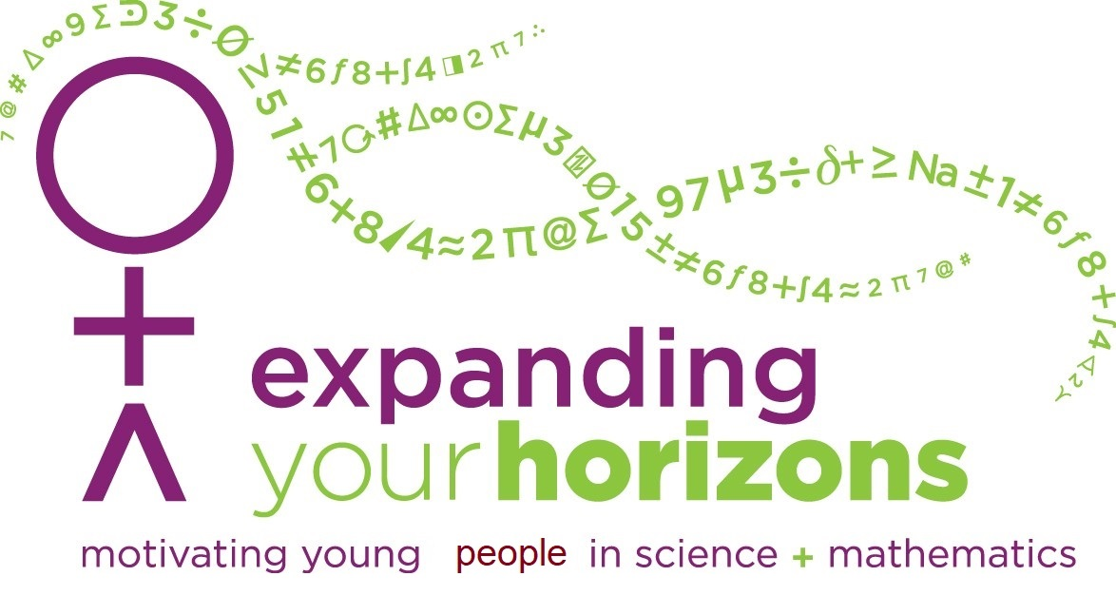July 15, 2025

Dear Math/Science Teachers and Administrators:

This packet of information is intended to describe, in detail, the upcoming **33rd annual Expanding Your Horizons conference on Saturday November 1, 2025** at Southern Illinois University Carbondale.

Please post the enclosed flyer and information letter on the school bulletin board and post on your social media page(s) if possible. As the workshops for 2025 are finalized they will be added to our website, <https://math.siu.edu/eyh/workshops.php>, be sure to check often. Feel free to make copies of the registration forms as needed and circulate to 5th, 6th, 7th, 8th, and 9th grade students. We would also like to invite parents and teachers to come to this conference. (If you plan to attend, please make sure to register early.) Participants can now pay by credit card online!

**Registration:**

* **ALL participants MUST register online.**
* Register online at <https://math.siu.edu/eyh/>. Look under “EYH LINKS” on the left for the Registration Link **or** use the link in the body of the page. Note: This online registration only requires the names and general information of attendees.
* Photo Consent Form must also be filled out online. See <https://math.siu.edu/ehy/>. Look under “EYH LINKS” on the left for the Online Photo Consent Form **or** use the link in the body of the page.

If you decide to bring a group of students, we will email you a week before the event to confirm your list of participants.

**Registration Fees** (includes lunch)**: Early registration deadline is October 18th to get the discount.**

* On or before October 17th:  $10.00
* October 18th-28th: $17.00 – No guarantee after October 28th.
* Pay by credit card. Follow the instructions on this page: <https://math.siu.edu/eyh/>. After completing your online registration, you will need to return to the main page to pay by credit card.
* If you prefer to mail your fees: Make the check payable to SIUC and mail to: SIUC-Mathematics, EYH 2025, 1245 Lincoln Drive, MC 4408, Carbondale, IL 62901

**Registration Deadline:** October 28, 2025

Please note, SIU is committed to gender inclusivity. As such, this event is open to all person, including boys.

In addition, we are able to offer:

* $50 gift certificate to the teacher who has the

most students in attendance.

* Money for a bus if your school brings more than 25 students.
* 3 CPDUs for teachers. (Please let us know ahead of time if you would like the CPDUs.)

If you have any questions, comments, or suggestions about the program, please call Thara Lowndes at (618) 453-6569. You may also e-mail your questions to [EYHMath@siu.edu](mailto:eyh@math.siu.edu). We look forward to seeing you on Saturday, November 1st.

We are trying to get the word out about our conference so,

teachers, if you have access to parents’ emails or parents have access to their child’s grades, we would appreciate it if you would post our website for parents to see.

Yours sincerely,





Thara Lowndes & Vina Castelli, Co-Chairs