rMake sure that your scantron matches the color of this page. Read ALL directions carefully before beginning the exam.

- Anyone found using a graphing/programmable calculator or cell phone during the final exam will receive a grade of “0”.
- You may write on this exam. You may not use other paper unless you raise your hand and it is provided by an instructor.
- If you finish after 45 minutes, you can take this test with you. If you finish prior to 45 minutes, you will need to turn this test in along with your scantron.
- Please turn in your scantron to YOUR teaching assistant and have a picture ID ready.
- On your scantron, encode your name as specified on the scantron, encode your Dawgtag as your “Identification Number,” and encode your Section # “OP” under the area labeled “Special Codes.”

SAMPLE SCANTRON
INSTRUCTOR/DAYS IS GIVEN:

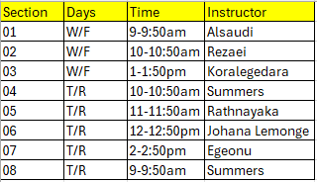
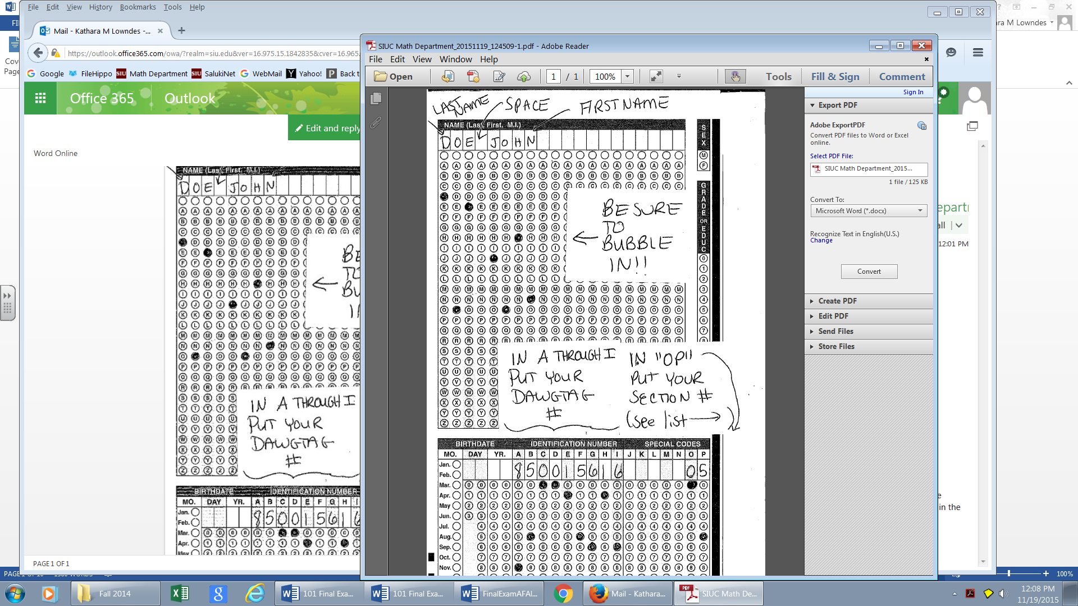

Use the table to answer the following 2 questions. Give your answer as a reduced fraction.
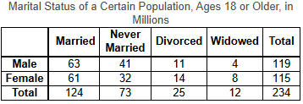

- If one person is selected from the population described in the above table, find the probability that the person is widowed.

A) $\frac{32}{85}$ | B) $\frac{3}{8}$ | C) $\frac{16}{127}$ | D) $\frac{2}{39}$ | E) None of these

- If one person is selected from the population described in the above table, find the probability that the person is female, given that this person is widowed.

A) $\frac{2}{3}$ | B) $\frac{1}{3}$ | C) $\frac{115}{234}$ | D) $\frac{8}{115}$ | E) None of these

- A restaurant offers 7 main courses, 3 vegetables, 6 beverages, and 3 desserts. If one item is selected from each of the four groups, in how many ways can a meal be ordered?

A) 39 | B) 378 | C) 19 | D) 343 | E) None of these

- Suppose your credit card has a balance of $5400 and an annual interest rate of 12%. You decide to pay off the balance over five years. If there are no further purchases charged on the card,
- How much must you pay each month? (round to the nearest dollar)
- How much total interest will you pay? (using your answer from part i)

- (i) $120 (ii) $1500 | B) (i) $87 (ii) $1800 | C) (i) $120 (ii) $1800 | D) (i) $87 (ii) $1500 | E) None of these

- You borrow $7000 from your parents and agree to pay back $7525 in one year. What simple interest rate, to the nearest tenth of a percent, will you pay?

A) 5.3% | B) 8.0% | C) 7.5% | D) 5.5% | E) None of these

- Express 7/6 as a percent. Round to two decimal places.

A) 0.12% | B) 1.17% | C) 11.67% | D) 116.67% | E) None of these

- The scores on a test are normally distributed with a mean of 60 and a standard deviation of 12. What is the score that is one-half standard deviations below the mean?

A) 48 | B) 66 | C) 54 | D) 42 | E) None of these

Use the following data set to answer the next 2 questions.
8, 13, 18, 23, 28
- Find the standard deviation. Round to the nearest hundredth.

A) 7.37 | B) 6.52 | C) 7.91 | D) 7.14 | E) None of these

- Find the midrange.

A) 38 | B)18 | C)28 | D)38.8 | E) None of these

- Suppose that a certain car has the following average operating and ownership costs.
Average Costs per Mile
 | Operating | Ownership | Total
Car A | $0.24 | $0.74 | $0.98
Car B | $0.12 | $0.31 | $0.43

If you drive 40,000 miles per year, by how much does the total annual expense for Car A exceed that of Car B over eight years?

A) $248,000 | B) $144,000 | C) $154,499.98 | D) $176,000 | E) None of these

- Find the taxable income for a taxpayer who earned wages of $57,000, received $2500 in interest from a savings account, and contributed $2000 to a tax-deferred retirement plan. They are entitled to a personal exemption of $3800 and a standard deduction of $5950. They contributed $3000 to charity, and they paid $8000 in state taxes.

A) $47,750 | B) $36,750 | C) $41,700 | D) $42,700 | E) None of these

- Determine the number of Hamilton circuits in a complete graph with 9 vertices.

A) 40,320 | B) 5040 | C) 120 | D) 64 | E) None of these

- Use the 2016 FICA tax rates in the table below to solve the problem.
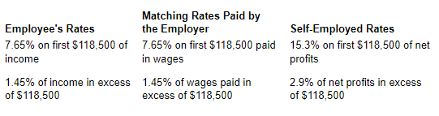

If a taxpayer is self-employed and earns $152,000, what are the taxpayer’s FICA taxes?
A) $10,783.50 | B) $19,102.00 | C) $11,269.25 | D) $19,290.00 | E) None of these

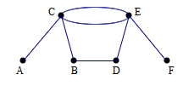
- Does the graph have an Euler path, and Euler circuit, both, or neither?

A) Euler path | B) Euler circuit | C) both | D) neither | E) Additional information needed

- A set of data items is normally distributed with a mean of 130 and a standard deviation of 16. What percentage of data items falls above a 142?

A) 77.34% | B) 80.28% | C) 22.66% | D) 19.72% | E) None of these

- If you are given odds of 18 to 28 in favor of winning a bet, what is the probability of winning the bet?

A) $\frac{18}{28}$ | B) $\frac{9}{14}$ | C) $\frac{10}{28}$ | D) $\frac{9}{23}$ | E) None of these

- A single six-sided die is rolled twice. Find the probability of rolling an odd number the first time and a number greater than 2 the second time.
A) $\frac{1}{3}$ | B) $\frac{3}{4}$ | C) $\frac{2}{3}$ | D) $\frac{1}{4}$ | E) None of these
- A bank offers a CD that pays a simple interest rate of 5.5%. How much must you put in this CD now in order to have $15,000 in 5 years? (Round up to the nearest cent)

A) $11,764.71 | B) $8,250 | C) $10,001.08 | D) $12,474.82 | E) None of these

- The price of a home is $187,000. The bank requires a 20% down payment. Assume all other costs will be taken care of at settlement and not incorporated into the loan. Determine the amount of the mortgage.

A) $37,400 | B) $190,960 | C) $149,600 | D) $127,000 | E) None of these

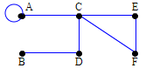
- In the following graph, what are the even vertices?

A) C | B) C,E | C) C,D,E,F | D) A,C,D,E,F | E) None of these

- Suppose that you decide to buy a car for $28,635, including taxes and license fees. You saved $8000 for a down payment and can get a five-year car loan at 5.83%. Find the monthly payment on the loan.

A) $460.41 | B) $397.30 | C) $871.44 | D) $551.33 | E) None of these

- Calculators were purchased at $100 per dozen and sold at $30 for three calculators. What is the profit on six dozen calculators?

A) $120 | B) $70 | C) $20 | D) $80 | E) None of these

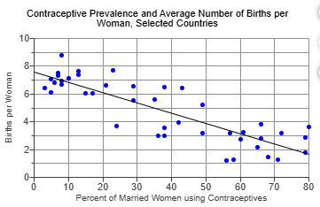
- Look at the scatter plot given and determine what type of correlation is displayed. Select the correct answer.

A) No correlation
B) Strong negative correlation
C) Strong positive correlation
D) Weak negative correlation
E) Weak positive correlation

- Change the following mixed number to an improper fraction. Simplify your answer.
$$14\frac{5}{6}$$

A)$\frac{89}{6}$ | B) $\frac{89}{5}$ | C) $\frac{6}{89}$ | D) $\frac{5}{6}$ | E) None of these

- One person earns ​$70,000 per year. Another person earns ​$4250 per month. How much more does the first person earn in a year than the​ second?
A) $16,471 | B) $17,000 | C) $19,000 | D) $27,500 | E) None of these

- At the time of her grandson’s birth, a grandmother deposits $4000 in an account that pays 9% compounded monthly. What will be the value of the account at the child’s twenty first birthday, assuming that no other deposits or withdrawals are made during this period? Round answers to the nearest dollar.

A) $29,400 | B) $11,560 | C) $26,291 | D) $75,600 | E) None of these

- Find the value of the annuity to the nearest dollar.
Periodic deposit: $1500 at the end of every three months
Rate: 5.25% compounded quarterly
Time: 8 years

A) $63,000 | B) $59, 178 | C) $62,375 | D) $11,178 | E) None of these

Use the frequency distribution to answer the next 2 questions.

- Find the mode for the data items in the frequency distribution.

A) 5 | B) 3,4,5 | C) 3,4 | D) 3.5 | E) None of these

- Find the mean for the data items in the frequency distribution. Round to the nearest tenth.

A) 4.5 | B) 4.0 | C) 5.1 | D) 4.3 | E) None of these

- You run into the grocery store for a few items. You buy a gallon of milk for​ $5.79, a loaf of bread for​ $2.69, a package of ground beef for​ $7.19, a bag of lettuce for​ $2.29, and your favorite snack mix for​ $3.69. Estimate to the nearest dollar what your total cost will be.

- $22.00 B) $19.00 C) $15.00 D) $18.00 E)$17.75

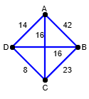
- Use the given graph and the nearest-neighbor algorithm to find a Hamilton circuit that begins at vertex B.

A) BDCAB | B) BDACB | C) BCADB | D) BCDAB | E) None of these

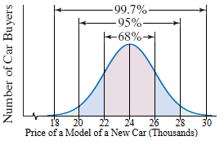
- The figure illustrates a normal distribution for the prices paid for a particular model of a new car. The mean is $24,000 and the standard deviation is $2,000. Use the 68-95-99.7 rule to find what percentage of buyers paid less than $20,000.

A) 16% | B) 2.5% | C) 5% | D) 0.15% | E) None of these

- Advice from most financial advisers states to spend no more than 28% of one’s gross monthly income for one’s mortgage payment. What is the maximum amount a family should spend each MONTH on a mortgage payment, supposing the family has a gross ANNUAL income of $42,000?

A) $1,042 | B) $1,416 | C) $980 | D) $796 | E) None of these

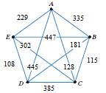
- Use the complete, weighted graph on the right to find the total weight of the following Hamilton circuit.
A, B, E, D, C, A

A) 761 | B) 1272 | C) 1503 | D) 1403 | E) None of these

- You are dealt one card from a standard​ 52-card deck. Find the probability of being dealt the ace of hearts.
A) 0 | B) $\frac{2}{13}$ | C) $\frac{1}{13}$ | D) $\frac{1}{52}$ | E) None of these

- One option in a roulette game is to bet $12 on red.​ (There are 18 red​ compartments, 18 black​ compartments, and two compartments that are neither red nor​ black.) If the ball lands on​ red, you get to keep the $ 12 you paid to play the game and you are awarded $ 12. If the ball lands​ elsewhere, you are awarded nothing and the $ 12 that you bet is collected what is the game’s expected value (rounded to the nearest cent)?

A) -$0.63 | B) $0.63 | C) $0.00 | D) -$1.37 | E) None of these

- Consider a political discussion group consisting of 5 ​Democrats, 7 ​Republicans, and 6 Independents. Suppose that two group members are randomly​ selected, in​ succession, to attend a political convention. Find the probability of selecting two Democrats.
A) $\frac{25}{324}$ | B) $\frac{5}{13}$ | C) $\frac{5}{9}$ | D) $\frac{10}{153}$ | E) None of these

- You select a family with three children. If M represents a male​ child, and F represents a female​ child, the set of equally likely outcomes for the​ children's genders is​ {MMM,​ MMF, MFM,​ MFF, FMM,​ FMF, FFM, FFF​ }. Find the probability of selecting a family with fewer than 6 female children.

A) $\frac{1}{3}$ | B) 0 | C) 1 | D) $\frac{3}{8}$ | E) None of these

- Suppose that the local sales tax rate is 7% and you purchase a car for $29,200. What is the car’s total cost, including tax?

A) $31,992 | B) $41,200 | C) $31,244 | D) $31,978 | E) None of these
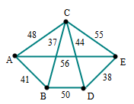
- For the following graph, which of the following edges does not appear in the minimum spanning tree?

A) AB | B) BC | C) CD | D) DE | E) None of these

The last page of this exam is the formula sheet and z-score table. You may tear that page out of the exam for your reference.

You must use a pencil to fill in your scantron!

Final Exam Formula Sheet. FEEL FREE TO TEAR OFF THIS LAST DOUBLE SIDED PAGE

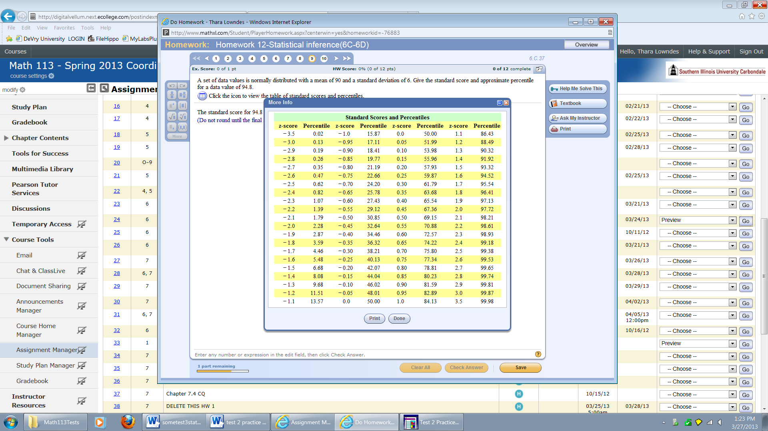

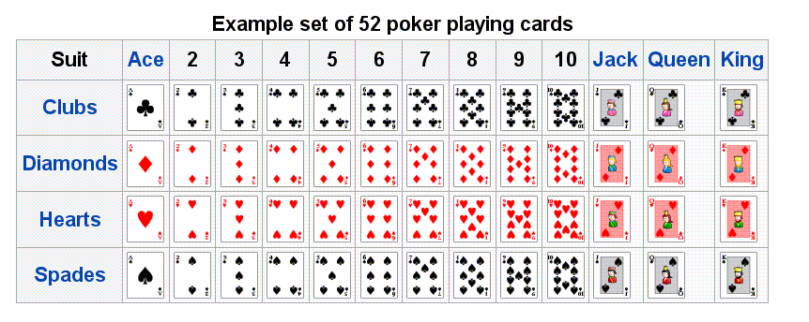

P = the principal amount invested or borrowed (present value)
A = accumulated amount (future value) r = the interest rate (as a decimal)
t = time (in years) n = number of compound periods per year
PMT = loan payment

6) Savings formula (Annuities)
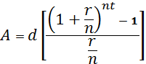
7) Loan Formula (Amortization Formula):

1) Simple Interest:
$$Interest=Prt$$

2) Future Value (with Simple Interest):
$A=P(1+rt)$ or $P=\frac{A}{(1+rt)}$
3) Compound Interest -finite # of compound periods:
(Loan or Investment)
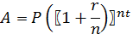$A=P{\left(1+\frac{r}{n}\right)}^{nt}$ or $P=\frac{A}{{\left(1+\frac{r}{n}\right)}^{nt}}$
4) Compound Interest –continous
$$A=Pe^{rt}$$
$e≈$ 2.71828 (but use e-button on calculator)

5) Savings Formula (Annuities)
P = deposit made at the end of each time period
$$A=\frac{P\left[{\left(1+\frac{r}{n}\right)}^{nt}-1\right]}{\left(\frac{r}{n}\right)}$$

